Objective
The primary objective of the system is to improve traffic safety by detecting potential traffic collisions. Basically, there are three types of collisions that are quite common. The first type of collision occurs on the same lane where the vehicles hit with each other on the tail or head. As shown in the diagram below:
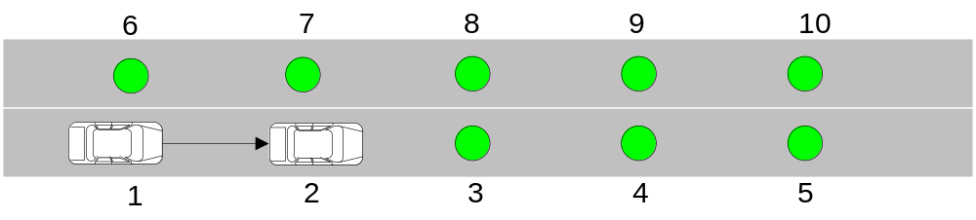
If the 2 vehicles are too close, the second car may hit the tail of the first car so a collision may occur.
The second type of collision occurs when the vehicles are trying to switch lane. As shown in the diagram below:
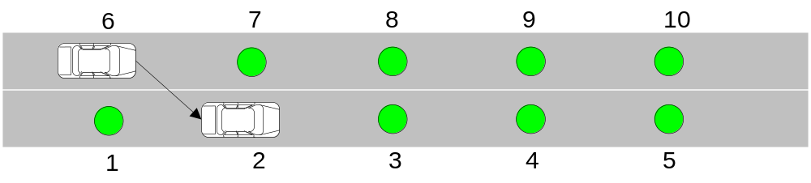
When the first car suddenly decides to switch its lane without knowing there is another car on the other lane, a collision can occur.
The third type of collision occurs in the intersections, as shown in the diagram below:
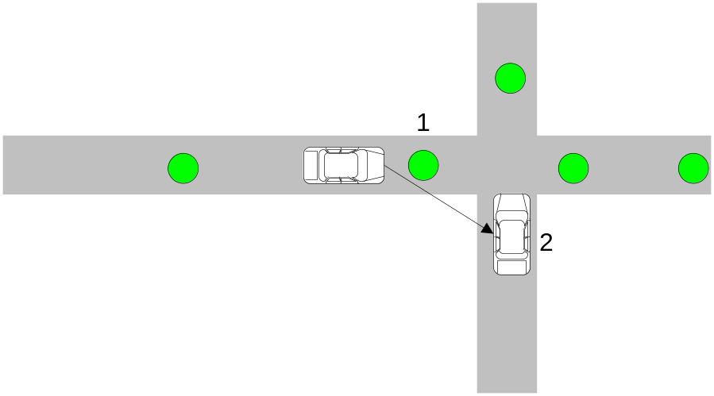
This type of collision occurs when vehicles are driving too fast near the intersection.

Collision Detection
Collision can be detected by measuring the speed of the vehicles. For the first collision case above, assume there are two vehicles with speedand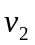. The time interval between the arrivals of these two vehicles is. The distance between two consecutive sensors is. As a result, in order to avoid collision within the distance, we should have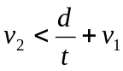
Potential collision in the second case above can also be estimated by the speedand, time intervaland distance. In order to avoid collision, a vehicle can be allowed to switch lane only whenis satisfied.
Collision in the intersection can be estimated in a similar manner. Suppose the speed of the 2 vehicles areand. The distance between the sensor at the road end and the intersection is. Then, the formula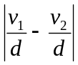should be smaller than a threshold.

System Model
Number of sensors on a certain road:

Radio Model
One-hop only
Packet loss rate: 

Wakeup Model
Each time when a sensor is woken up, it stays active for a time period of t.
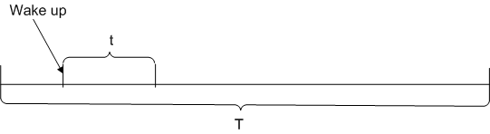

Schemes
Always-on: all the sensors are active at all the time.
Random wake-up: all the sensors are woken up randomly and spontaneously.
Normal wake-up: when a sensor detects a car, it will wake up its next sensor.
Normal wake-up + automatically wake up: in addition to being woken up by the previous sensor, each sensor will also wake up spontaneously.
Selective wake-up: sensor will be woken up depending on the potential danger on the road. In this scheme, each sensor will try to determine the speed of each vehicle. If the speed of vehicle is not known, the sensor will wake up the next sensor. If the speed can be calculated, the sensor will try to determine the safety of that vehicle and then choose another sensor to wake up.

Accuracy
Always-on:
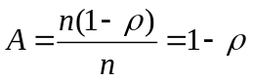
Normal wake-up:
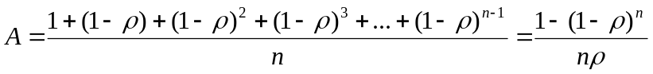
With the help of self-wake-up:
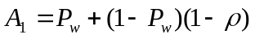
For convenience, let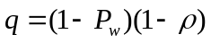
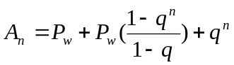
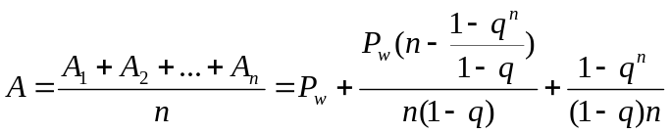
Selective wake-up:

Energy Consumption
Always-on:
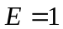
Normal wakeup:
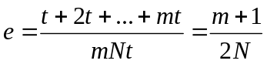
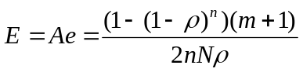
Normal wakeup with self-wakeup:

